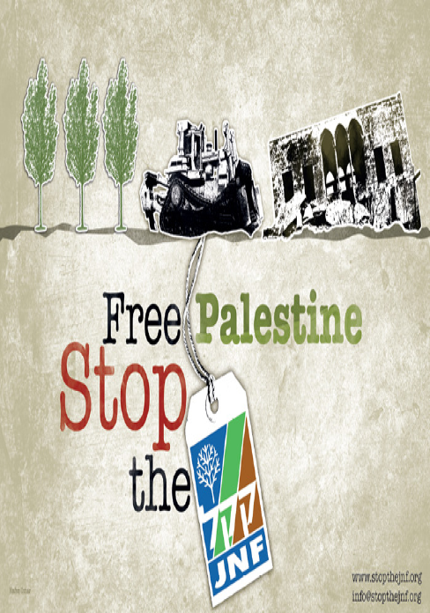
Picket the Jewish National Fund Dinner & its Honouree John Baird
Sunday, June 7, 2015 5pm, Four Seasons Hotel (W. Georgia and Howe St.) Vancouver
No Greenwashing Apartheid! No Charity Status for the JNF!

In a classic "greenwashing apartheid” move, the Jewish National Fund is holding its annual Negev dinner to raise funds to build a park in Sderot, a “green lung” they claim. At the same time, not far away, the Bedouin village of Al Araqib in the Negev has been destroyed more than 80 times by Israeli and JNF paramilitary forces, but the Palestinians of the village refuse to surrender, returning time and time again to rebuild (more info at stopthejnf.org).
The JNF also notes in its publicity for the event that the park will “honour the memory of the 66 soldiers who were killed during Operation Protective Edge”, better known as Israel’s horrific aggression on Gaza last summer.
And equally fitting is the guest speaker that the JNF is honouring for the evening, John Baird who signed the infamous January 18, 2015 Memorandum of Understanding as one of his last acts as Canada’s Foreign Minister that committed to develop “a coordinated, public diplomacy initiative both bilaterally and in international and multilateral fora to oppose boycotts of Israel, its institutions, and its people within three to six months". This is the same John Baird that in an address to another 2012 JNF dinner explained to the audience, “Why Israel holds such a special place in my heart.”

Organized by: Canada Palestine Association, email info@cpavancouver.org
Endorsed by: Independent Jewish Voices-Vancouver

