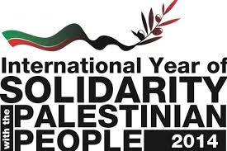 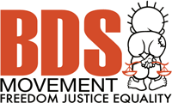
Date: Tuesday, December 2, 2014, 7PM
Place: SFU Downtown Harbour Centre, Labatt Hall
515 W. Hastings, Vancouver
Admission by donation (suggested $5-10)
Brian Avery, U.S. social justice activist shot by Israeli forces in 2003, will talk about his experiences. Cindy and Craig Corrie, the parents of the late Rachel Corrie, the American student brutally killed by an Israeli military bulldozer, will also be speaking.
Vancouver Premiere of Palestinian Film – Resistance Recipes
Join us to mark the International Day (and Year) of Solidarity with the Palestinians
Commemorate Palestinian Steadfastness (Sumoud)
Support the Global Boycott, Divestment and Sanctions BDS Movement

Organized by Canada Palestine Association
Sponsors: Rachel Corrie Foundation and Youth for Palestine
Email: info@cpavancouver.org

