International Day of Solidarity with the Palestinian People
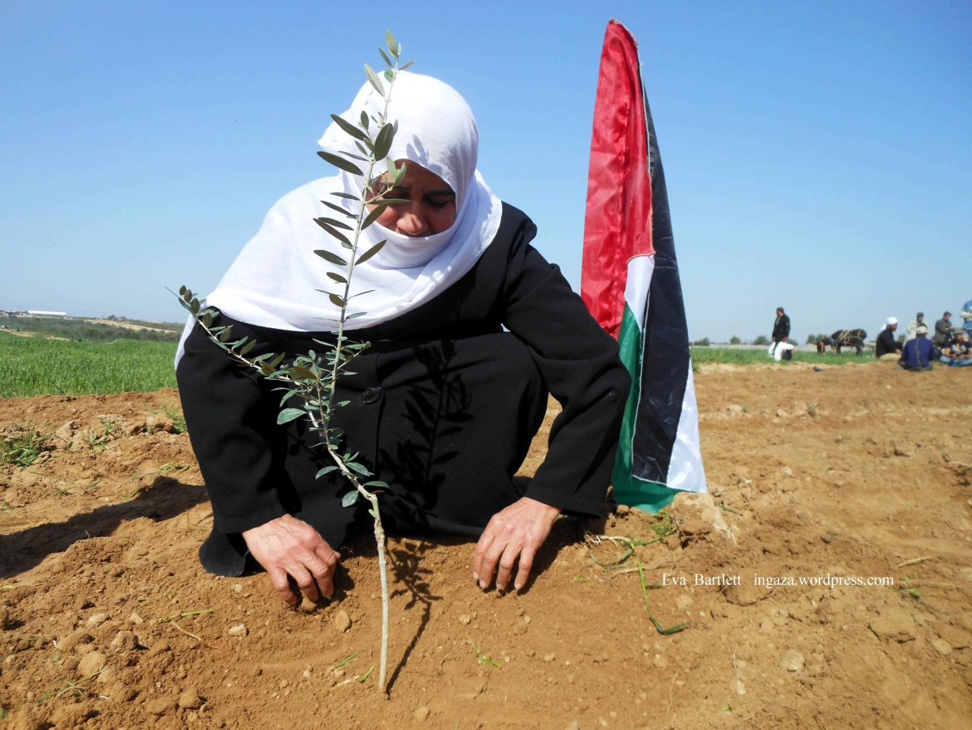
Gaza in Crisis: Eyewitness Reports
Guest speaker - Eva Bartlett, human rights activist and journalist who lived in Gaza
With Kevin Neish, just returned from Gaza

Friday, November 29th, 2013, 7PM
SFU Harbour Centre, Fletcher Challenge Theatre
515 W. Hastings, Vancouver
Admission by donation ($5-10 suggested)
Organized by: Boycott Israeli Apartheid Campaign, Canada Palestine Association, Gaza’s Ark and Independent Jewish Voices
Email: info@cpavancouver.org or ijv-vancouver@ijvcanada.org

