International Day of Solidarity with the Palestinian People
Cindy and Craig Corrie, the parents of the late Rachel Corrie, the American student who was brutally killed by an Israeli military bulldozer, will be speaking in Vancouver on November 29th. The Corries will update us on their lawsuit against the Israeli government.
Special musical guest David Rovics.
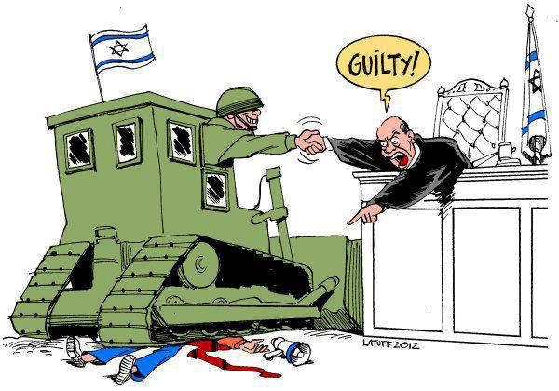

7PM Thursday, November 29th, 2012
Doors open 6:30 pm
SFU Downtown Harbour Centre, Fletcher Challenge Theatre, 515 W. Hastings, Vancouver

Admission by donation ($10 suggested) • All proceeds to The Rachel Corrie Foundation
Info at http://www.cpavancouver.org/ or email info@cpavancouver.org

